**Project Design Phase-II**

**Data Flow Diagram & User Stories**

|  |  |
| --- | --- |
| Date | 28 June 2025 |
| Team ID | LTVIP2025TMID54367 |
| Project Name | **ShopEZ** |
| Maximum Marks | 4 Marks |

**Data Flow Diagrams:**

A Data Flow Diagram (DFD) is a traditional visual representation of the information flows within a system. A neat and clear DFD can depict the right amount of the system requirement graphically. It shows how data enters and leaves the system, what changes the information, and where data is stored.

**Example:**

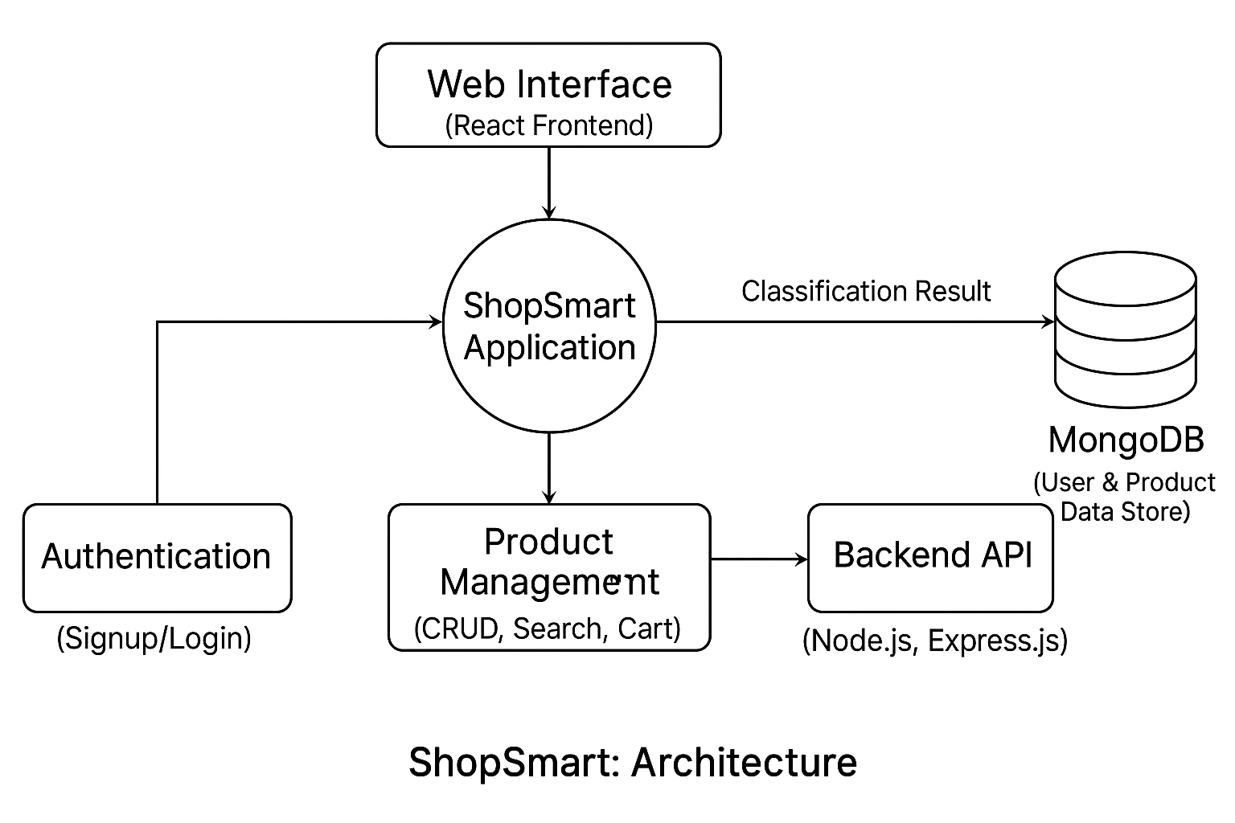

ShopEZ

**ShopEZ**

**User Stories**

| **Sprint** | **Functional Requirement (Epic)** | **User Story Number** | **User Story / Task** | **Story Points** | **Priority** | **Team Members** |
| --- | --- | --- | --- | --- | --- | --- |
| Sprint-1 | User Registration & Authentication | USN-1 | As a user, I can sign up and log in securely to access the platform.. | 3 | High | Chemalamarri Vyshnavi |
| Sprint-1 | Product Catalog | USN-2 | As a user, I can view a list of products with details like price, description, and images.. | 3 | High | B Praveen Varma |
| Sprint-1 | Search & Filter | USN-3 | As a user, I can search products and apply filters like price, category, and ratings. | 4 | High | B Praveen Varma |
| Sprint-2 | Cart Functionality | USN-4 | As a user, I can add or remove items from my shopping cart. | 3 | High | B Praveen Varma Chemalamarri Vyshnavi |
| Sprint-2 | Order Placement | USN-5 | As a user, I can proceed to checkout and place orders using a simple flow | 4 | Medium | Chemalamarri Vyshnavi |
| Sprint-2 | |  | | --- | |  |   Payment Integration | USN-6 | As a user, I can make payments securely using online methods (e.g., Razorpay/UPI). | 5 | High | Chemalamarri Vyshnavi, Amballa Vigneswari |
| Sprint-3 | Order Tracking | USN-7 | As a user, I can track the status of my placed orders. | 2 | Medium | B Praveen Varma, B Manogna |
| Sprint-3 | Admin Dashboard | USN-8 | As an admin, I can manage products, view orders, and handle inventory. | 4 | High | Chemalamarri Vyshnavi, B Manogna |
| Sprint-3 | Product Recommendations | USN-9 | As a user, I can get smart product suggestions based on my search/purchase history | 3 | Low | B Manogna, Amballa Vigneswari |
| Sprint-3 | Final Testing & Deployment | USN-10 | As a team, we want to test the complete app and deploy it to production. | 3 | High | All Members |